H.T No
Regulations:
A17

Sreenidhi Institute of Science and Technology
(An Autonomous Institution)
Code No: 6A242 Date: 03-Nov-2021 (AN)

B.Tech I-Year II- Semester External Examination, Oct/Nov - 2021 (Supplementary)
NETWORK ANALYSIS (ECE and ECM)

Time: 3 Hours Max.Marks:75

Note: a) No additional answer sheets will be provided.
b) All sub-parts of a question must be answered at one place only, otherwise it will not be valued.
c) Missing data can be assumed suitably.

ANSWER ANY 5 OUT OF 8 QUESTIONS. EACH QUESTION CARRIES 15 MARKS.

Bloom's Cognitive Levels of Learning (BCLL)

Remember | L1 | Apply | L3 | Evaluate | L5
Understand | L2 | Analyze | L4 | Create | L6

 |  |  | BCLL | CO(s) | Marks
1. | a) | In the circuit, shown below find the different node voltages and the currents I₁, I₂ and I_{3.}  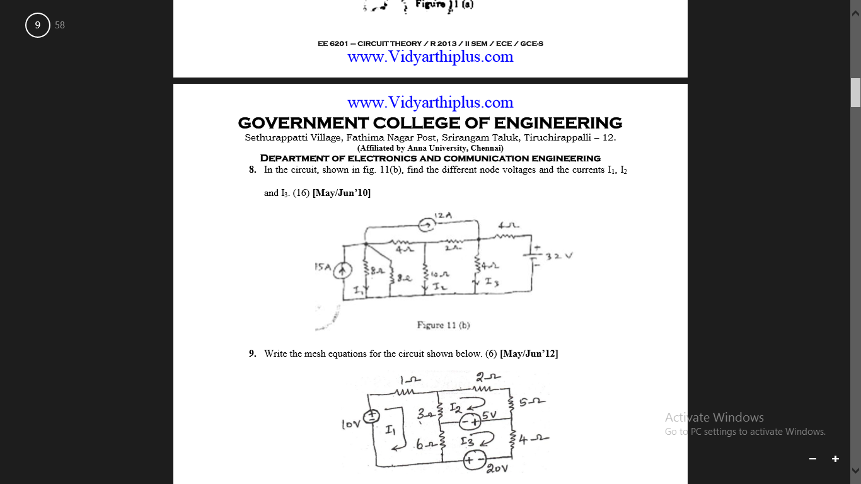 | L5 | CO1 | [8M]
 | b) | Determine the current I_{L} in the circuit shown below  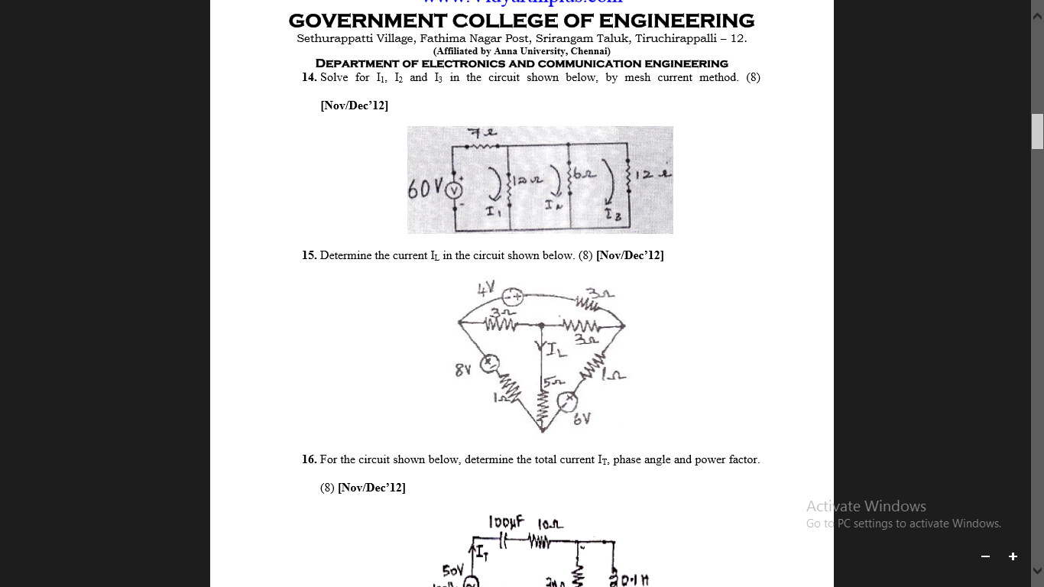 | L5 | CO1 | [7M]
2. | a) | A parallel RLC circuit has R=5kΩ , L=8mH and C=60mF. Determine:  i) the resonant frequency ii) the bandwidth iii) the quality factor | L5 | CO2 | [8M]
 | b) | A series-connected circuit has R=4Ω, L=25mH, Calculate the value of C that will produce a quality factor of 50. Calculate ω_{1,} ω₂ and Bandwidth. Determine the average power dissipated at ω=ω₀ , ω₁ and ω_{2.} Take V_{m}=100V. | L5 | CO2 | [7M]
3. | a) | Find the source voltage, Vs, if the voltage V₁ = 50V  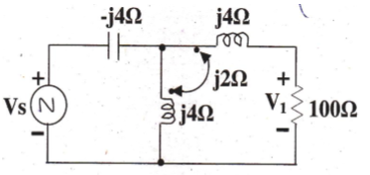 | L5 | CO3 | [8M]
 | b) | Two coupled coils have a self inductance of L₁ = 100mH and L₂ = 400 mH. The coupling coefficient is 0.8. Find M. If N₁ is 1000 turns, what is the value of N₂? If a current, i₁ = 2 sin (500t) Amps through the coil 1,find the flux φ₁ and the mutually induced voltage V_{2M.} | L4 | CO3 | [7M]
4. | a) | State Thevenin’s theorem and explain with a neat circuit diagram. | L1 | CO4 | [8M]
 | b) | Use source transformation to find V_{o} in the below figure.  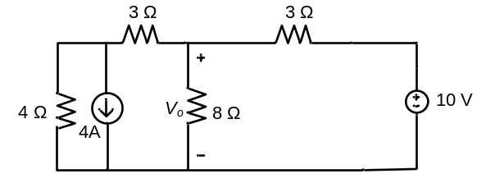 | L5 | CO4 | [7M]
5. | a) | Obtain the Y parameters for the circuit shown.  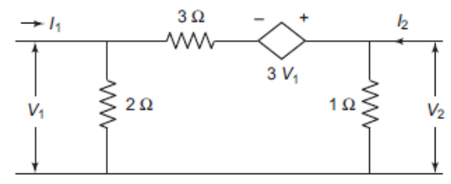 | L4 | CO5 | [8M]
 | b) | Find ABCD parameters of the network shown.  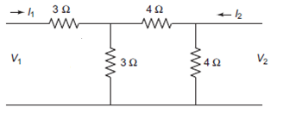 | L5 | CO5 | [7M]
6. | a) | A series R-C circuit with R = 10Ω and C = 2F has a sinusoidal voltage source 200 sin (500t +θ ) applied at time when θ = 0 . Find the expression for current. | L5 | CO6 | [8M]
 | b) | Find the complete solution for the current in a series R-L-C circuit when excited by a sinusoidal voltage source. | L5 | CO6 | [7M]
7. | a) | Find the value of resistance R, if the current is I=11A and source voltage is 66V as shown in below figure.  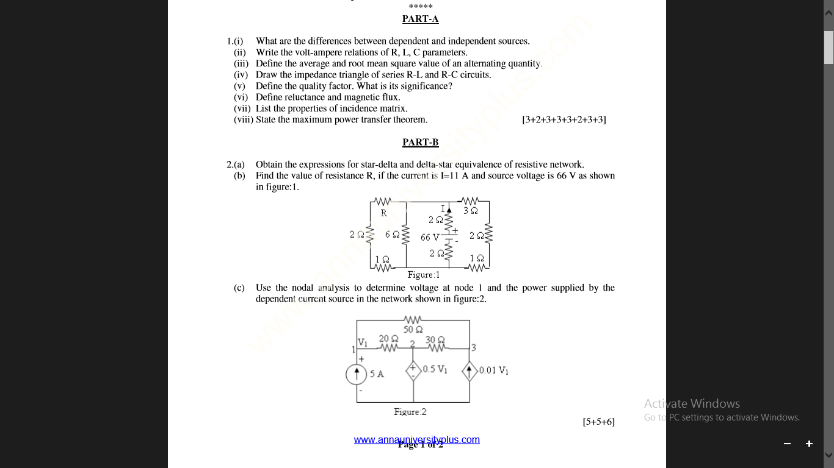 | L5 | CO1 | [8M]
 | b) | A coil having an inductance of 100mH is magnetically coupled to another coil having an inductance of 900mH. The coefficient of coupling between the coils is 0.45. Calculate the equivalent inductance if the two coils are connected in (i) series opposing and (ii) parallel opposing | L4 | CO2 | [7M]
8. | a) | State and explain Millman’s theorem. | L1 | CO4 | [8M]
 | b) | Explain Self and Mutual inductance with the help of a neat diagram. | L2 | CO5 | [7M]

-- 00 -- 00 –

